Photo Voltaic Cells Project
Student Name
Institution Affiliation
Course
Date

Abstract
Recently, there has been proliferated use of renewable energy sources globally. Notably, the sun is the most significant and sustainable source of energy. The use of solar cells to directly convert sunlight to electricity defines Photo Voltaic (PV) aspect. The production of solar cell fabrication involves several provisions and technologies based on high conversion proficiency and low cost. For instance, Silicon is first applied to produce solar cells. However, its downsides are lower efficiency and high costs. Remarkably, Thin-film solar cells could also manufacture electrical energy because they second generational fabricated solar cell technology. The study is going to compare the ancient silicon solar cells and CdTe (Cadmium Telluride) using their material properties (Ramanujam et al., 2020).
Introduction
Solar cells are more valuable because of their low manufacturing cost and high conversion efficiency. The high efficiency of Thin-film solar cells is explained by the possession of several layers incorporated within a single cell. Ultimately, the property aids in the reduction of current loss in the solar cells. Electrical energy can be formed upon the striving of light's spectrum on the surface of the solar surface. The process involves the absorption of photon's energy. Also, the absorption of the photon’s energy could form heat energy. The introduction of more dissimilar buffer and absorber layers could enhance the efficiency of solar cells in the modules.
The proportion of material needed for the development of active material of the solar cell can be reduced by Thin-film technologies. Contrarily, silicon solar panels have a single pane of glass. The Thin-film panels are two times heavier than crystalline silicon panels. A lot of technology companies have incorporated the use of Thin-film technologies to wafer silicon cells because of the flexibility and success of the first solar with lower cost. However, they have not been embraced as mainstream solar products because of the low efficiency when applied to vast area consumption per watt manufacturing. The most common outdoor Thin-film technologies are CdTe, CIGS, and A-Si. CdTe technology has major cost competitive advantages. CdTe technology's cost is 30% less CIGS, and 40% less A-Si (Kwak et al., 2020).
Approaches to Thin-Film
The majority of materials that display the photovoltaic effect could be utilized in the production of solar cells. The conditions that these solar cells need to fulfill include high conversion efficiency; availability of cheap nontoxic material and durability (up to twenty years). Nearly, 80% of the recent commercial Photo Voltaic modules are silicon-made. Other semiconductors like CIGS display operate at higher efficiency levels. Alternatively, CdTe can operate at a low production cost. The Thin-film technology stands out to potentially operate at low cost as well as high effectiveness. The property is important for the commercial viability of the PV cells.
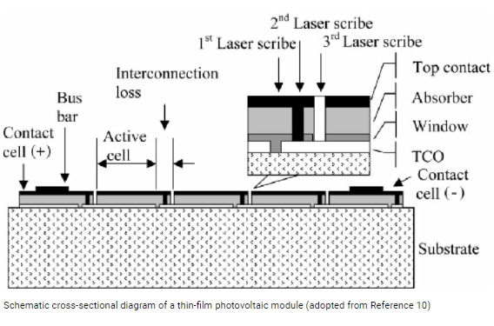
The main benefit of Thin-film solar cells is the less energy needed for processing. It means operations could be carried out at a lower cost. Also, materials needed for large-scale production are possible. Several simpler approaches to deposition have been applied to utilize the production of polycrystalline CdTe stratums. These are approaches incorporate close-space sublimation, electrode positioning, screen printing, spraying, and sputtering. Short circuit current, fill factor, and open-circuit voltage are the parameters used to characterize the solar cell yield. Also, the energy gap is another primary factor used to determine the electrical conductivity of a solid. The energy gap ranges between 1.3 t0 1.6 eV for the maximum output of solar cells. The energy gap for CdTe is at 1.45 eV which is the optimum cell output. The best materials for photovoltaic cells include the nature of band-band transitions and value of the energy gap; the ability to work under concentrated radiations; the ability of the material to create efficient collecting structure; and defects and doping value of the photo carrier’s lifetime (Kim et al., 2018).
Silicon Solar Cells
These solar cells are traditional made of silicon. They are currently the most effective cells suitable for residential application. Consequently, these traditional silicon cells are durable compared to non-silicon cells. Nonetheless, at higher temperatures, they face the peril of losing their efficiency. Silicon-based cells are divided into four clusters (Bosio et al., 2018).
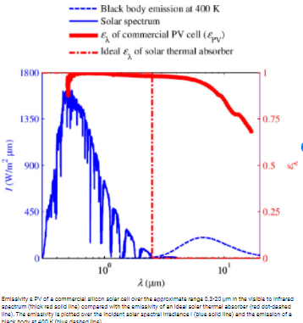
Monocrystalline Silicon Cells
The most ancient solar cell technology was manufactured from thin silicon wafers. Notably, the solar cells are derived from carefully slicing a huge single crystal under controlled conditions. The common outlook of these cut cells are panels where the crystals are arranged a few inches across in a grid. Monocrystalline silicon cells have an efficiency rate of 24.2% implying that one can get more electric power from a particular panel at a time. Nevertheless, it is cumbersome to grow large crystals of untainted silicon. Notably, prices of fresh silicon and building panels using Monocrystalline solar cells have declined recently facilitating the improvement of production methods. Apart from competition in the production of silicon Monocrystalline solar cell panels, the cells may lose their efficiency when temperatures are proliferated to exceed 25⁰C. Therefore, they have to be installed cautiously to allow for air circulation over and below the panels to enhance their effectiveness (Niewelt et al., 2018).
Polycrystalline Silicon Cells
Production of silicon wafers molds using multiple silicon crystals is cheaper compared to using a single crystal. It is because the growth conditions do not require maximum supervision. Therefore, several silicon crystals entangle and grow collectively. The panels are less efficient but cheaper compared to Monocrystalline panels per unit area. Their efficiency rate is 19.3% (Belkaid et al., 2019).
Amorphous Silicon Cells
Most electronic devices are manufactured using amorphous silicon cells. Here, silicon is placed on a thin layer of a backing substrate like glass, plastic, and metal. On rare occasions, layers of silicon can be doped in several ways to retort to dissimilar wavelengths of light. They could be placed on top of each other to enhance efficiency. The production approaches could be multifaceted but it is less energy-intensive compared to crystalline panels. When the panels are produced on a large scale, the prices lower during the processing (Cao et al., 2020). The benefit of applying thin layered silicon is that the panels could be made more flexible. The downside is their efficiency is at 10% which is less effective and not good for the installation of roofs.
The Hybrid Silicon Cells
It is one of the newest trends in the energy industry. Many companies are devising ways of merging different materials to create solar cells with durability, proliferated efficiency, and declined costs. For instance, Sanyo Company launched a Hybrid cell (HIT) which had its amorphous silicon layer deposited on solo crystal wafers. It yields efficient solar which ultimately performs in the presence of indirect light. Also, it is difficult for it to lose efficiency when temperatures are increased (Park et al., 2019).
Cadmium Telluride (CdTe)
Solar cell fabrication is produced based on efficiency and low cost using different technologies and materials. The Thin-film CdTe centered Photo Voltaic cells are the most auspicious candidates for operating under low-cost conversion of Photo Voltaic energy since there is a chance that the reduced materials, stability of the cell operations, and reduced material could yield higher efficiency.
The benefit of CdTe solar cells is that they are manufactured from glass and polycrystalline materials. The second advantage is that the CdTe solar cells layer can be placed by applying several low-cost practices. Also, the CdTe solar cells have a high absorption coefficient (5*10ᶺ15/cm) with a direct optimum bandgap of 1.45 eV. It implies that all the possible photons with energy higher than the bandgap could be enthralled within the layer of the CdTe absorber. Therefore, it lowers the cost of material for CdTe-related solar cells. Ultimately, this is the aim of Photovoltaic cell researchers to apply less material by creating thinner cells (Munshi et al., 2018).
Selecting the CdTe cells having supersaturated outlook can help in modifying the baseline case to reduce costs and proliferate efficiency. In comparison to thinner CdTe solar cells, it has a higher cost and low efficiency of about 15%. Baseline cases could be modified in different ways which incorporate the reduction in thickness of the front contact through the insertion of a relevant buffer layer that causes a decline in cost. The layer proliferates the morphology of the window layer. Also, it decreases the leakage current because of the pinholes. An example of these buffer layers is the ZnO (Shah et al., 2021).
Secondly, the selection of the relevant window layer with a great energy gap and diminishing the thickness. As a result, it proliferates the blue region response belonging to the cells. Consequently, the surface recombination current located at the window layer is diminished. Thirdly, when the layer in the back surface is inserted, it decreases the back surface recombination and reduces the height of the hole-barrier. As a result, this proliferates the efficiency of Jsc and Voc. Finally, the absorber layer lifespan can be made longer by surging the minority and doping. The Voc and FF impact is increased (Shah et al., 2021).
The Comparison
The abundance and nontoxic characteristics of silicon are significant to CdTe cells. Recalling the optimum bandgap for a specific layer to have an optimum Jsc and Voc ranges from 1.4 to 1.6eV. However, the energy gap displayed by silicon solar cells stands at 1.1eV. It is inferior to CdTe with 1.45eV. Notably, 80% of the commercial manufacturing and production is linked to first-generation solar cells in comparison to Thin-film solar cells which are the second generation. Remarkably, the market share for first-generation solar cells is diminishing.
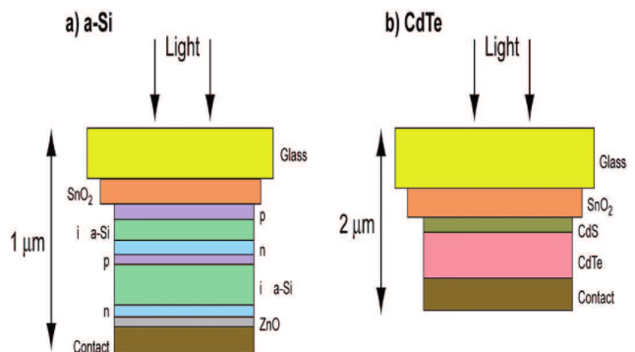
The benefits of Thin-Film solar cells incorporate minimal production costs; decreased mass; achieving a declined cost per watt; little support required during the installation of the panels on rooftops; and allowing flexibility of materials during the fitting of the panels (Yan et al., 2020). The downsides include a wider spectral absorption range resulting in High career motilities; proliferated toxicity benefits of traditional silicon cells, and lower efficiency rates compared to wafer-based silicon solar cells. The limitations of traditional silicon cells include high energy required for the sawing and growing of the ingots; the cells need expensive production technologies; a substantial amount of energy photons is lost as heat at the violet and blue endpoint of the spectrum; and it is easier for electrons from other molecules to collide with an opening from a previous photoexcitation (Zhang et al., 2018).
Conclusion
Second-generation photovoltaic cells provided more benefits compared to the traditional ones. Another finding is that the determination of solar cells is guided by conversion efficiency and the low cost of the related cells. Also, Silicon cells are more efficient than CdTe. The comparison is successful upon applying pure silicon. Furthermore, energy requirement during the production process explains the high prices in relation to the power output. When CdTe cells are made thinner, the energy, material, time, and cost needed is decreased thereby surging its efficiency. Generally, Thin-Film solar cells like the CdTe are economical when applied to make solar cells when associated with traditional silicon cells.

Reference
Belkaid, A., Colak, I., Kayisli, K., Sara, M., & Bayindir, R. (2019). Modeling and simulation of polycrystalline silicon photovoltaic cells. In 2019 7th International Conference on Smart Grid (icSmartGrid) (pp. 155-158). IEEE.
Bosio, A., Rosa, G., & Romeo, N. (2018). Past, present, and future of the thin film CdTe/CdS solar cells. Solar Energy, 175, 31-43.
Cao, S., Yu, D., Lin, Y., Zhang, C., Lu, L., Yin, M., & Li, D. (2020). Light Propagation in Flexible Thin-Film Amorphous Silicon Solar Cells with Nano textured Metal Back Reflectors. ACS applied materials & interfaces, 12(23), 26184-26192.
Kim, S., Park, J. S., & Walsh, A. (2018). Identification of killer defects in kesterite thin-film solar cells. ACS Energy Letters, 3(2), 496-500.
Kwak, J. I., Nam, S. H., Kim, L., & Y. J. (2020). Potential environmental risk of solar cells: Current knowledge and future challenges. Journal of hazardous materials, 392, 122297.
Munshi, A. H., Sasidharan, N., Pinkayan, S., Barth, K. L., Sampath, W. S., & Ongsakul, W. (2018). Thin-film CdTe photovoltaics–The technology for utility-scale sustainable energy generation. Solar Energy, 173, 511-516.
Niewelt, T., Richter, A., Kho, T. C., Grant, N. E., Bonilla, R. S., Steinhauser, B., ... & Schubert, M. C. (2018). Taking monocrystalline silicon to the ultimate lifetime limit. Solar Energy Materials and Solar Cells, 185, 252-259.
Park, H., Lee, Y., Park, S. J., Bae, S., Kim, S., Oh, D., & Yi, J. (2019). Tunnel oxide passivating electron contacts for high‐efficiency n‐type silicon solar cells with amorphous silicon passivating-hole contacts. Progress in Photovoltaics: Research and Applications, 27(12), 1104-1114.
Ramanujam, J., Bishop, D. M., Todorov, T. K., Gunawan, O., Rath, J., Nekovei, R., & Romeo, A. (2020). Flexible CIGS, CdTe, and a-Si: H-based thin-film solar cells: A review. Progress in Materials Science, 110, 100619.
Shah, D. K., Devendra, K. C., Muddassir, M., Akhtar, M. S., Kim, C. Y., & Yang, O. B. (2021). A simulation approach for investigating the performances of cadmium telluride solar cells using doping concentrations, carrier lifetimes, the thickness of layers, and band gaps. Solar Energy, 216, 259-265.
Yan, N., Zhao, C., You, S., Zhang, Y., & Li, W. (2020). Recent progress of thin-film photovoltaics for indoor application. Chinese Chemical Letters, 31(3), 643-653.
Zhang, Y., Zhao, Y., Duan, J., & Tang, Q. (2018). S-doped CQDs tailored transparent counter electrodes for high-efficiency bifacial dye-sensitized solar cells. Electrochimica Acta, 261, 588-595.

